**Task on Ansible-01**

1) Watch ansible-01 video and write down notes

* Done

2) Setup one master and two worker nodes in ansible

worker-01-02

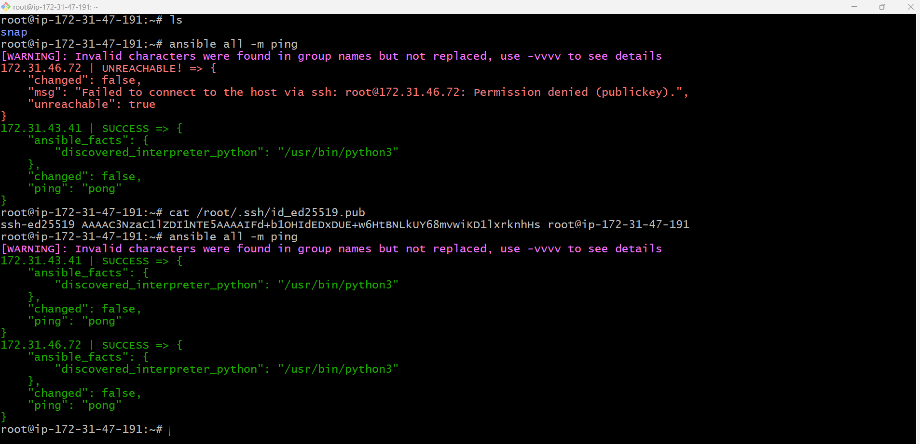

Worker 01-ssh-key  
Worker 02-ssh-key

3) Execute the adhoc command shared in #dvps-cloud-documents Channel

# To check the connetivity between slaves

ansible worker-01 -m ping  
ansible worker-01 -m ping -vvvv

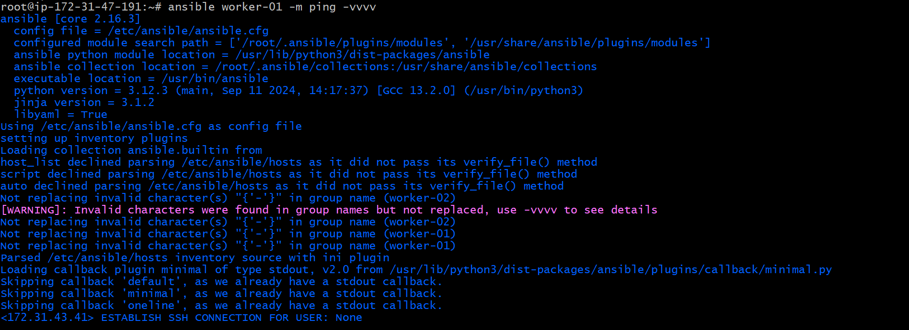  
ansible all -m shell -a uptime  
ansible all -m shell -a "mkdir ansible controller"

ansible all -m shell -a "ps -ef"  
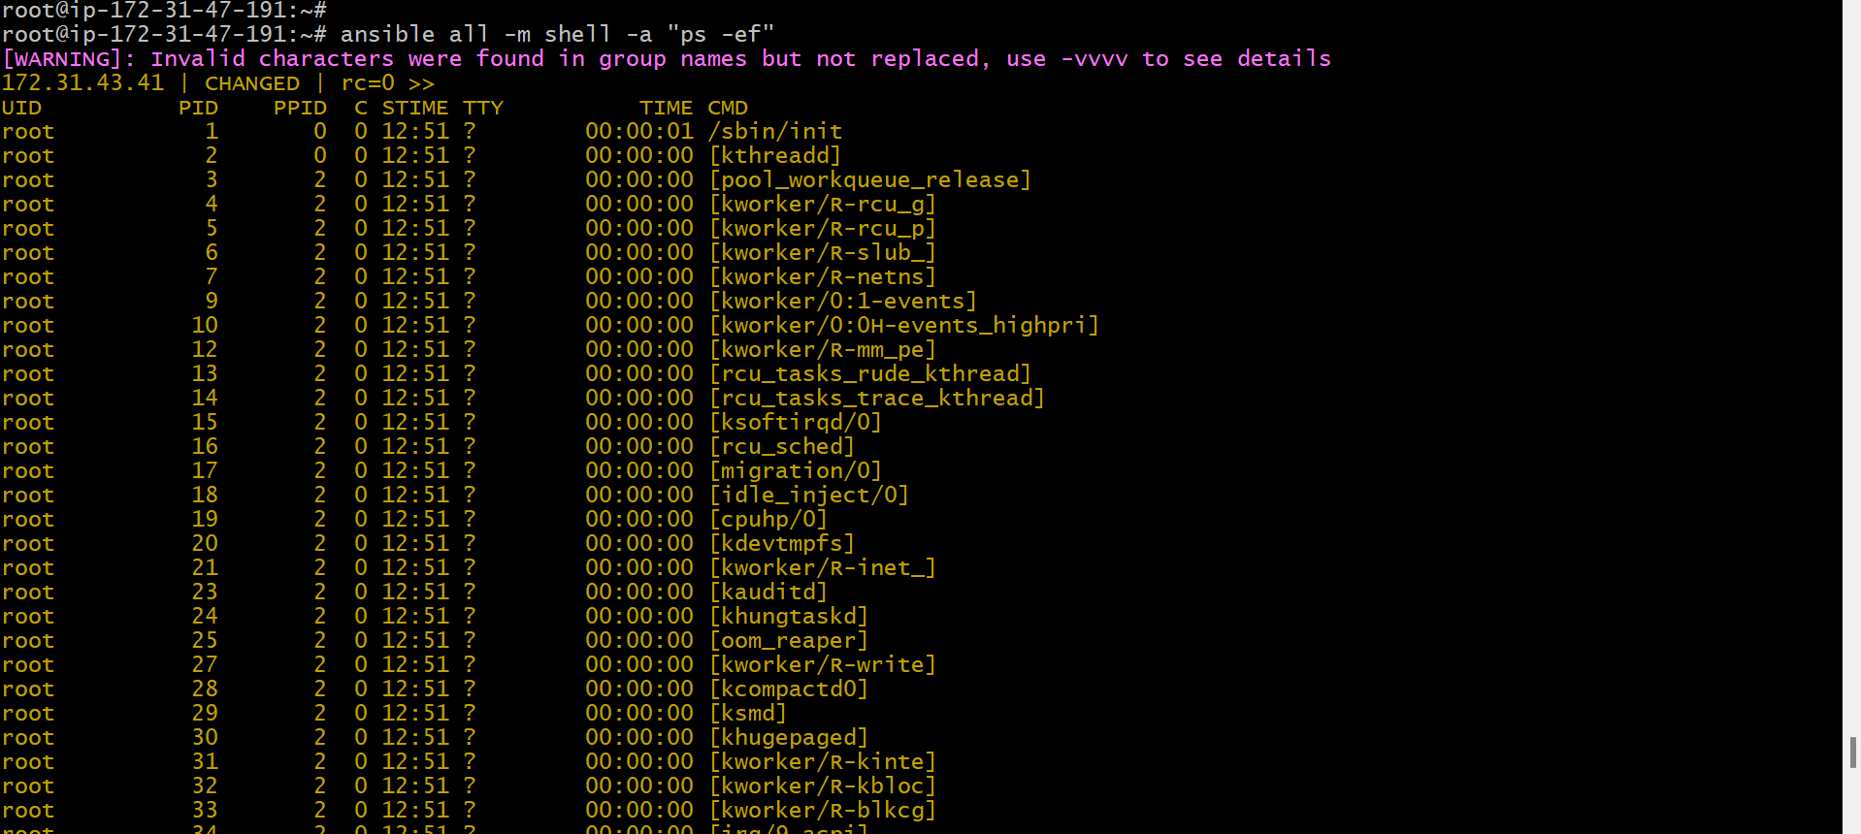  
ansible -i /root/nani_inventory nani -m ping  
# How to gather facts of slave machine

ansible all -m setup  
# check the free memory or memory usage of host

ansible all -a "free -m"  
ansible all -m yum -a "name=httpd state=installed"  
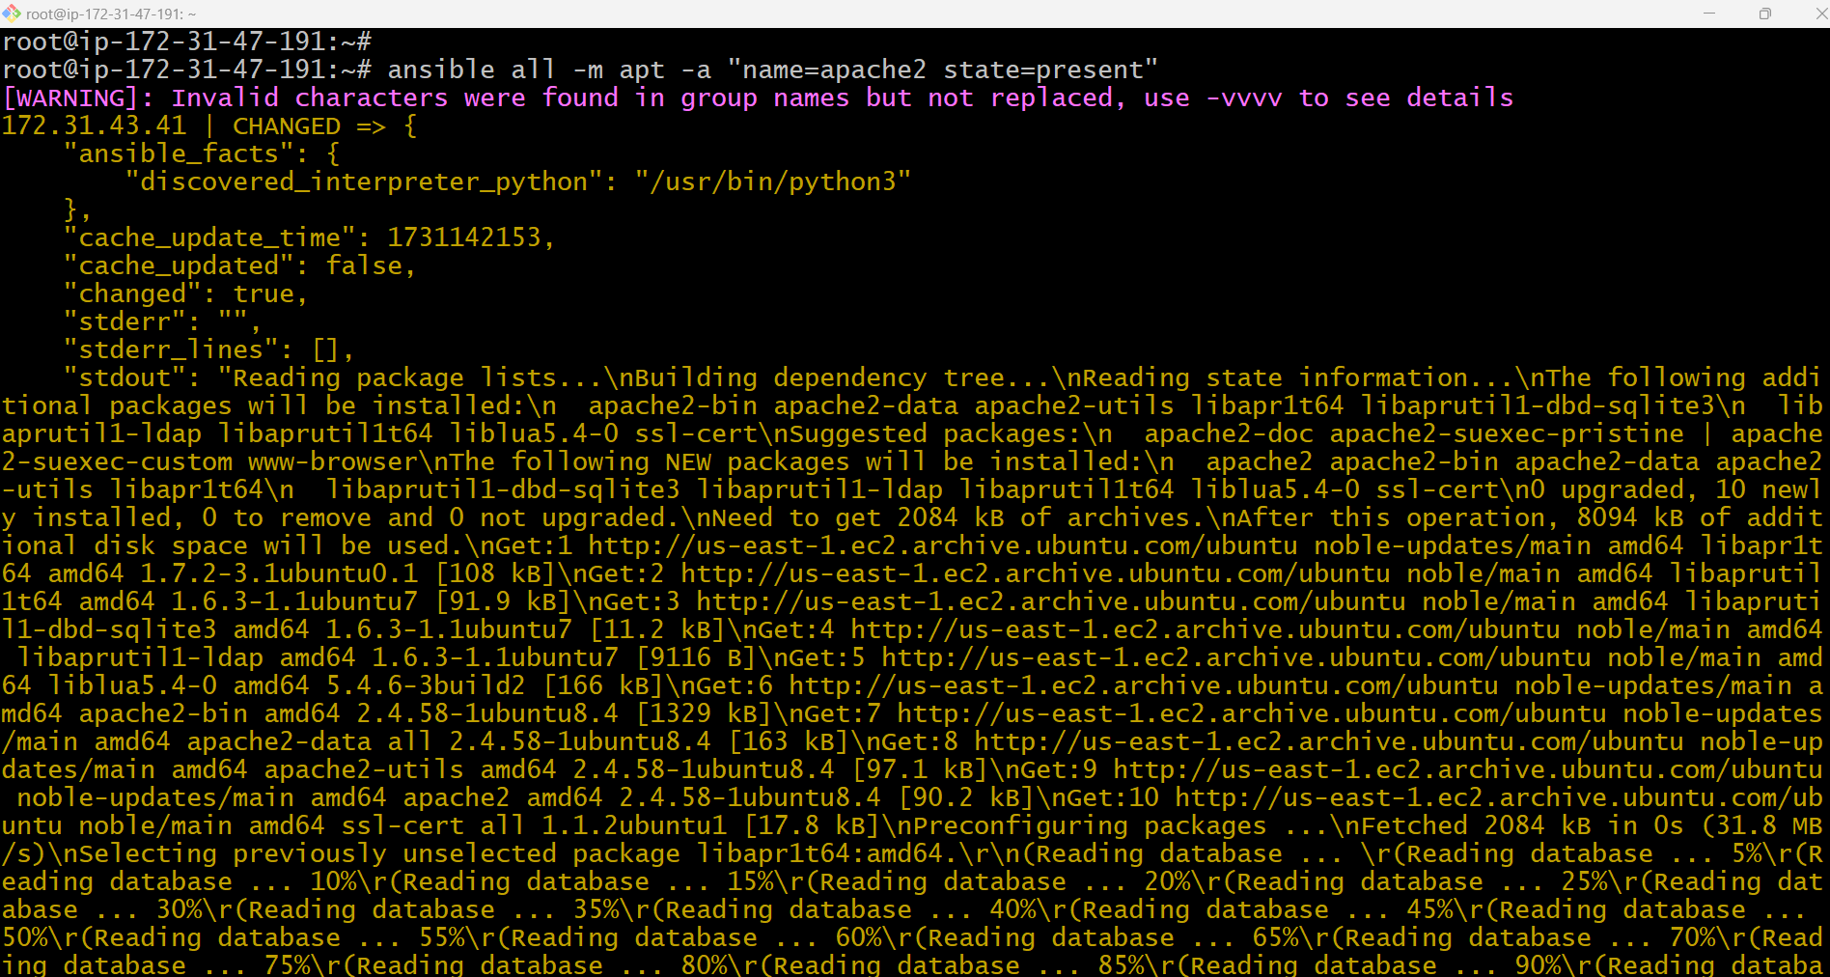  
ansible all -m apt -a "name=apache2 state=latest"  
worker-01  
worker-02  
ansible all -m service -a "name=apache2 state=stopped"  
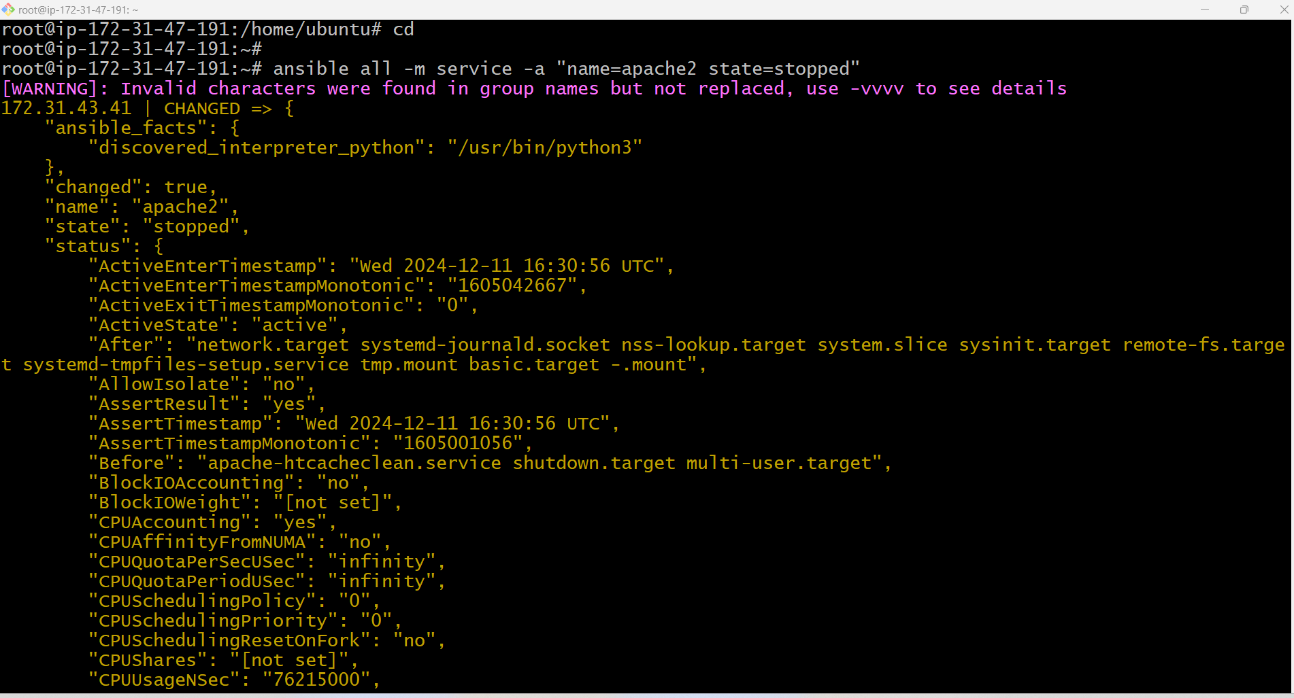  
Worker01  
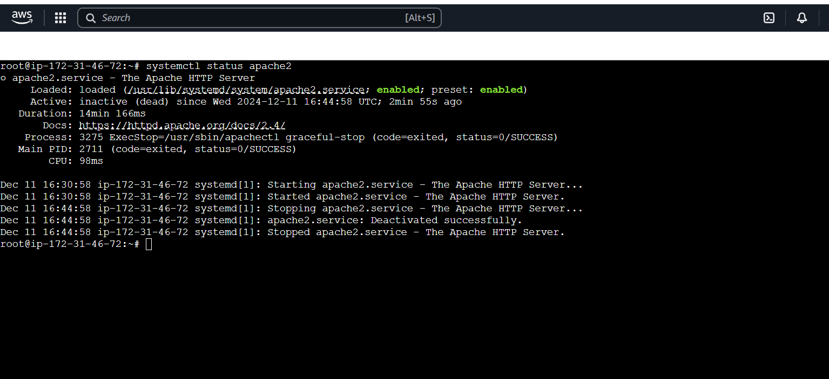  
Worker02

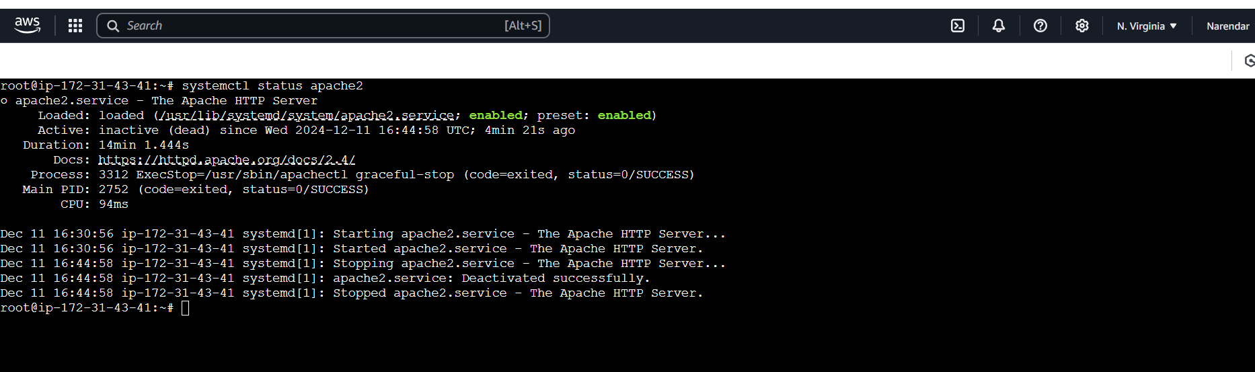  
To delete the service (apache2)  
ansible all -m apt -a "name=apache2 state=absent"  
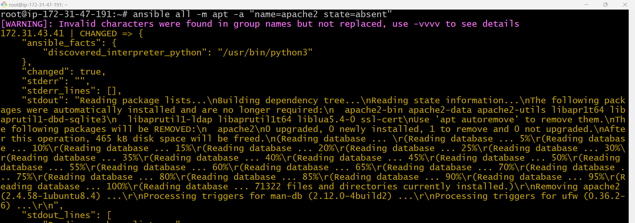  
Worker01  
Worker02

